LIVE SCIENCE
- EDUCATING UAE YOUTH -

Making its debut, Live Science, runs at Mushrif Central Park, Abu Dhabi from Sunday, January 31st to Saturday, March 5th, 2016. Brought to the UAE capital by the Abu Dhabi Education Council (ADEC) and Mubadala Development Company (Mubadala), the Abu Dhabi-based investment and development company, the event will welcome the UAE youth to discover and be inspired about aerospace, science and technology innovations.

Live Science combines Boeing’s Above and Beyond interactive science exhibition, exploring transformative innovations in aerospace, and a series of workshops presented by Lema?, the school outreach program, organized by Technology Development Committee (TDC) and held under the patronage of Her Highness Sheikha Shamsa Bint Hamdan.

Over the course of five weeks, students will have the opportunity to test their creative and critical thinking in Science, Technology, Engineering and Mathematics (STEM) subjects – all vital for future generations and the success of the UAE. Live Science aims to encourage young talent to explore, and pursue, an exciting future in aerospace and engineering fields. Live Science brings world-renowned innovations and technologies to the heart of Abu Dhabi in an interactive and engaging setting, and falls directly in line with the UAE’s long-term vision for economic diversification.

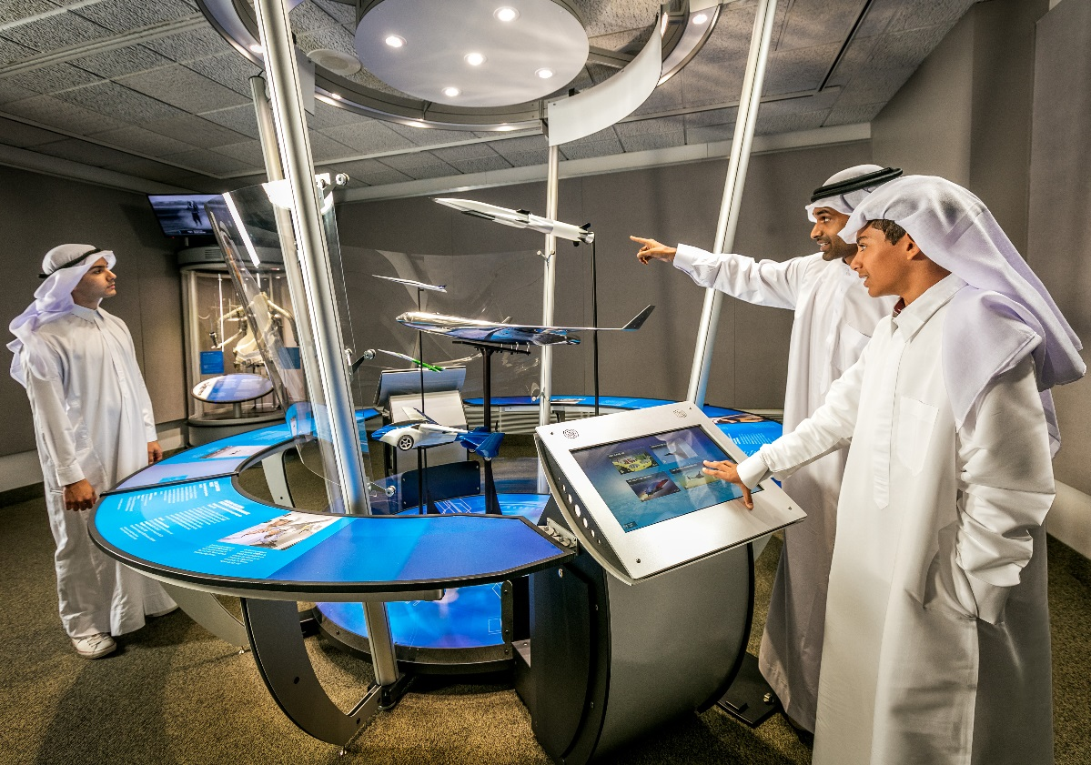

LIVE SCIENCE
- THE EXPEREIENCE -

ABOVE AND BEYOND EXHIBITION BROUGHT TO YOU BY BOEING | 31st January – 5th March

The exhibit, Above and Beyond, is produced by Evergreen Exhibitions in collaboration with U.S. space agency, NASA, and is presented by Boeing as part of the company’s centennial this year.
At the Above and Beyond exhibition, visitors will get the opportunity to experience the edge of space in a simulated space elevator, design and test their own supersonic fighter-jet in a virtual high-speed flying competition, immersive theatre, and inspiring stories, in addition to aircraft and spacecraft demonstrations from the first powered flights to the newest innovations on Earth and in space.

Looking back at the history of flight, one thing is abundantly clear: the sky was never the limit. Above And Beyond is a multisensory flight and aerospace exhibition that invites visitors to experience what it takes to make the “impossible” possible in and above the sky.

This unique learning opportunity is developed in collaboration with a host of renowned aviation specialists, aerospace experts, historians, archivists, teachers and educational programming professionals. These skilled partners bring science, technology, engineering and maths to new heights.

Above And Beyond gives direct access to immersive simulations, interactive design challenges, iconic historical touchstones, visionary concepts for the future and inspiring stories from game-changing innovators past and present.

From the time humans first got off the ground, the race was on to go above and beyond. Faster . . . further . . . higher . . . smarter! Today, these goals propel aerospace innovators to apply these learning principles to new discoveries and expand the boundaries of our universe. What if we could . . .

- Get airborne wherever and whenever we wanted?
- Fly faster than the speed of sound with supersonic flights that don’t make a lot of noise or burn too much fuel?
- Design ultra-green flying machines to carry more people to more places and, at the same time, treat the planet better?
- Invent super-smart flying robots to assist us in our daily lives, such as delivery-bots, eco-bots and more?
- Build a new generation of reusable space vehicles to make trips to Earth’s orbit as common as air travel?

Above And Beyond is more than a visit to the museum. It is a way to inspire young people to aim higher and go further in their studies.

INTERACTIVE WORKSHOPS BROUGHT TO YOU BY LEMA? | 31st January – 5th March
The Lema? by Abu Dhabi Technology Development Committee program engages Live Science visitors with its workshops. They are designed to be as interactive as possible to increase students’ interest in Science, Technology and Innovation fields. The unique, hands-on workshops at Live Science will push the limits of students’ imaginations and help them to become leaders in the ongoing evolution of science, technology, engineering and mathematics (STEM)

Grades 3-5
Radio Studio:
An interactive workshop that allows teams of students to get behind the microphone to record and transmit their very own radio broadcast into space, discovering the incredible applied science that enables this technology along the way. First, students will learn about the science of sound and how sound waves are converted into electrical signals; then they will record and process their own voices, ready to be sent as a radio broadcast to far off galaxies.

Lego Mindstorm Challenge:
A hands-on, interactive workshop that allows students to program their own robots. The workshop explores what a robot is and why they are useful, what the term “programming” means and how robots work.

Grade 6- 7
Secret of Space Digital Planetarium Show:
An inflatable spherical planetarium fitted with a digital projection system that throws images of stars, planets and other phenomena on to the inside surface of the planetarium. The show will explain the Solar System; its structure and movements of planets within it, followed by what is beyond the Solar System, the Milky Way, other galaxies, and the number of other stars and galaxies in the universe demonstrating its sheer size.

Lego Mindstorms Advanced Challenge Workshop:
A hands on, interactive workshop that allows students to programme their own robots while applying a context to the process. The workshop will focus on the work of the Mars Rover and other robots currently at work in space. Participants will be faced with a set of challenges set by ‘Mission Control’ to help rescue a trapped robot.

LIVE SCIENCE
- THE PRACTACALITES -

Dates: 31st January – 5th March
Times: Weekday public timings are from 4pm to 8 pm (Sunday to Thursday). Weekend public timings are from 4 pm to 9 pm (Friday & Saturday)
Registration: Workshops allocated on a first come first serve basis, arrive early to avoid disappointment
Access: Entrance and access to Live Science, including both Above and Beyond and Lema? workshops is complimentary. Entrance to Mushrif Central Park is AED 5.00 for ages four and above

For additional information and a complete schedule, please visit www.weyana.ae/livescience

